### শিক্ষা নিয়ে গড়বো দেশ তথ্য-প্রযুক্তির বাংলাদেশ

**Bangabandhu Sheikh Mujibur Rahman Digital University, Bangladesh**

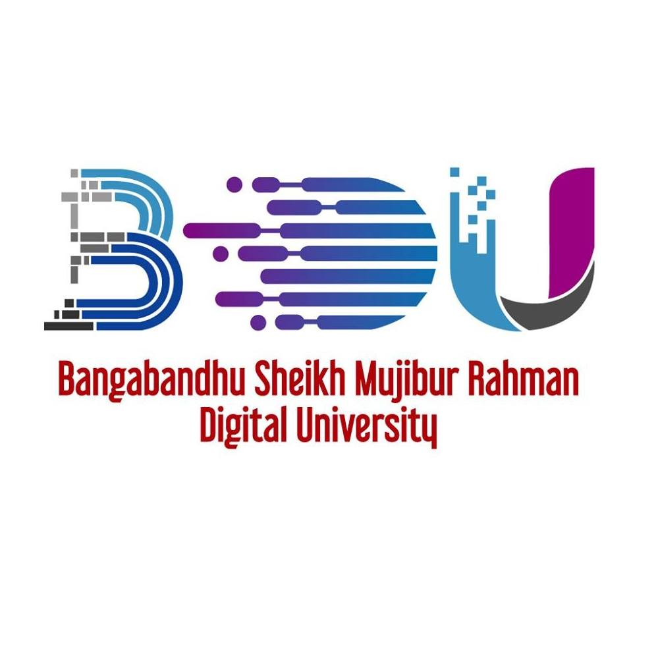

LAB REPORT-01

**COURSE NO.-ICT 4256**

**COURSE TITLE-COMPUTER NETWORKING LAB**

**SUBMITTED BY**

Mehrin Farzana

ID:2101013

Department of ICT

Session :2021-2022

Bangabandhu Sheikh Mujibur Rahman Digital University, Bangladesh

**SUBMITTED TO**

Md.Toukir Ahmed

Lecturer

Department of ICT, BDU

Bangabandhu Sheikh Mujibur Rahman Digital University, Bangladesh

**Date of Submission:7 February ,2023**